Review questions:

1. Absolute path is the path of where a particular file or directory is saved on the web server. A relative path points to the location of a file relative to the current working directory.
2. Include and Require take text/code/markup and copies it into the file that uses the statement. If the file doesn’t exist in Include you get an error and everything else is outputted. If the file doesn’t exist for Require than you get a fatal error and nothing is outputted other than the error message.
3. The include() looks if the file has been included once or not while include_once will do it the once and never include it again. It is best to just use include() since include_once requires extra work.
4. Because it will be read as html unless it is in php tags
5. Is used to know about the type of request method being used. (GET, POST, PUT)

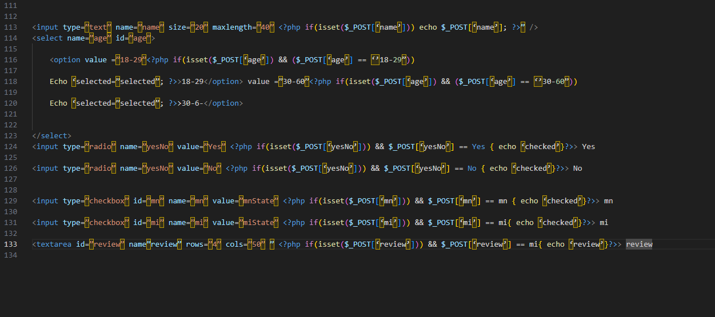

1. Check the HTML source page to see if there are errors
2. <?php function myFunction() {} ?>
3. <?php function name($first, $last){ echo $first.” “.$last;} ?>
4. <?php function name($first=”Jordan”,$last=”Merriman){} ?> If a function has a default value being called the value won’t change outside of the function
5. <?php Function square($a){return a*a}; echo square(4); ?>

2:

4:

5

