Review Questions:
- Method specifies how to send the data and the action is if the data should be sent after the form is submitted.
- Because PHP is also run through URL. If not run through URL you’ll just see the PHP code.
- By using double quotations you can a variable within the string.
- If/Else, While loops, for loops.
- Arrays
- Using empty() is to check if the variable is empty or not while using isset() is to check if the variable has a value or is null.
- Indexed arrays you give each value as an index and associative array stores (key, values) in it.
- 0 and 9
- A type of variable that can be used at any point in your code.
$_Get is usually from a form that is submitted and then data is sent to the URL
$_Post Usually gets its data that is submitted in a form and is posted after hitting submit
$_Cookie is a subset of $_Request
$_Request gets its value of the whatever variable is being requested
$_Session values are usually grabbed while the user is on the page. So if the page asks what your favorite color is you can us $_Session to keep that in memory and gets terminated once the user leaves the page
$_Server just grabs values of the server
$_ENV stores available environment variables
- Index:
For($i = 0; $i < array.count(); i++) {
Echo: I;
}
Associated:
For($movies as $titles => $ratings){
Echo “<tr><td>$ratings</td><td>$title</td></tr>
}
- The count function grabs the length of an array
- \n starts a new line within a string
- I would use a While loop if a specific condition is needed and to run while the condition is met. A for loop to iterate through something like outputting values of an index array and a foreach through a associative array
- The ++ is used for pre variable or post variable and adds 1 to the variable. Has to have a numeric value.
Pursue 1:
8.2.6

Pursue 3/5:
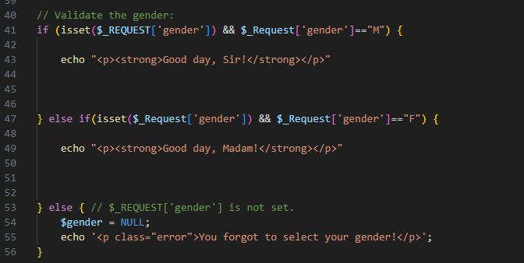
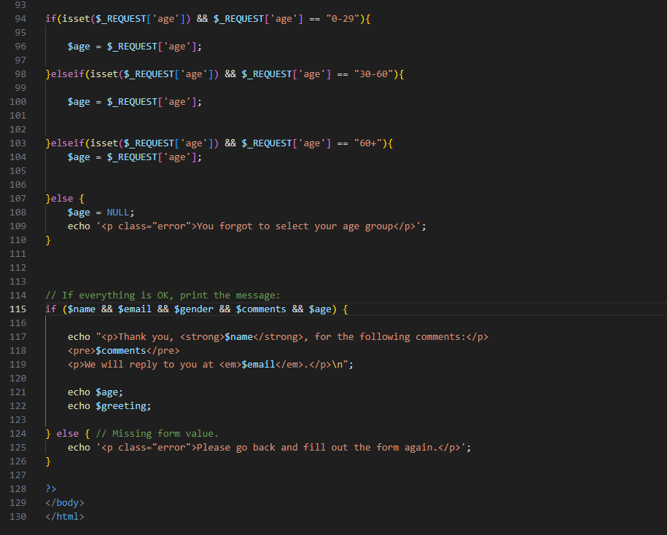
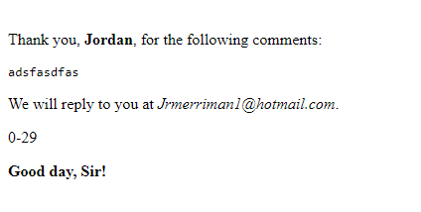
Pursue 8/9:
Shuffle() will shuffle and randomize the order of the array. Search() searches an array for a given value and returns the key. Keys() return all of the keys.
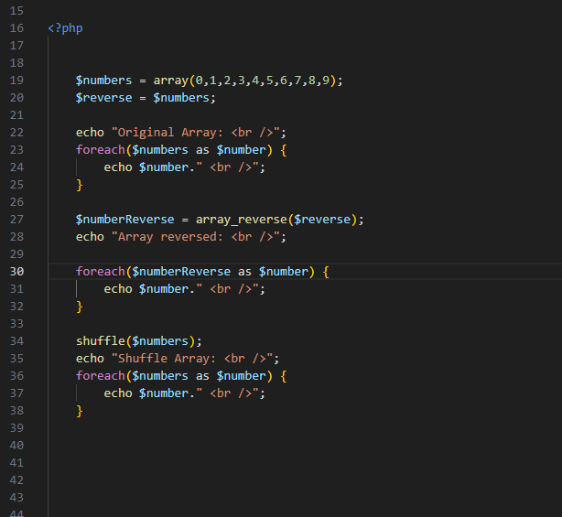
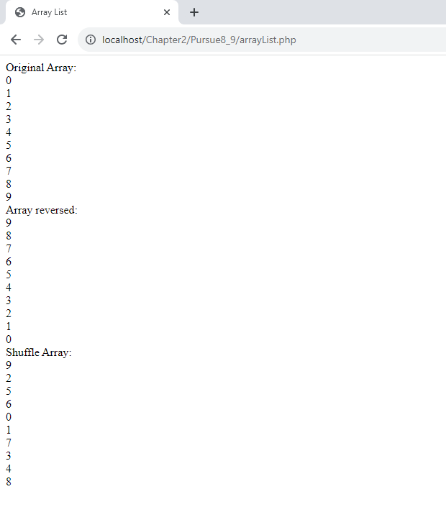
4 quiz questions:
True or False. Index arrays and associative arrays are the same thing? False
True or False? Isset looks to see if the value has been set or not? False
What does ! operator represent? B
- Constant variable
- Does not equal/ is not true
- Equals variable
- Is true

Ksort sorts an array by? A
- Key
- Largest value
- Smallest value
- Alphabetical

