Invite.html

Attendance.html

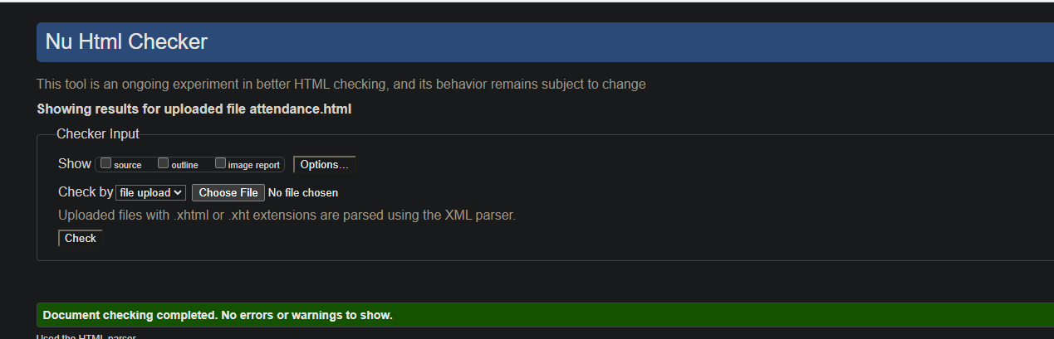

Partystyles1

Partystyles2

Print

Reset

